Git Interview Questions

What is Git? What do you use it for?
Git is software for tracking changes in any set of files. It is used for coordinating work among programmers collaboratively developing code during software development.

What is GitHub?
GitHub is a provider of Internet hosting for software development and version control using Git.

Difference between Git and GitHub?
Git is a technology that you use to track changes, GitHub is a service for storing the code and repositories.

Which command do you use to get a project from a remote repository?
- git clone <url_to_repo>

Explain how you make a commit?
- git add <filename>
- git commit -m “<commit message about changed implemented>”
- git push

Which command do you use to view changes you’ve made to a file?
- git diff

What is a .gitignore file?
A gitignore file specifies intentionally untracked files that Git should ignore. Each line of a gitignore file describes a pattern, files that match this pattern will be ignored. [Source and more details]
For example, *.log pattern inside .gitignore file will tell git to NOT track any of the project files that end with .log

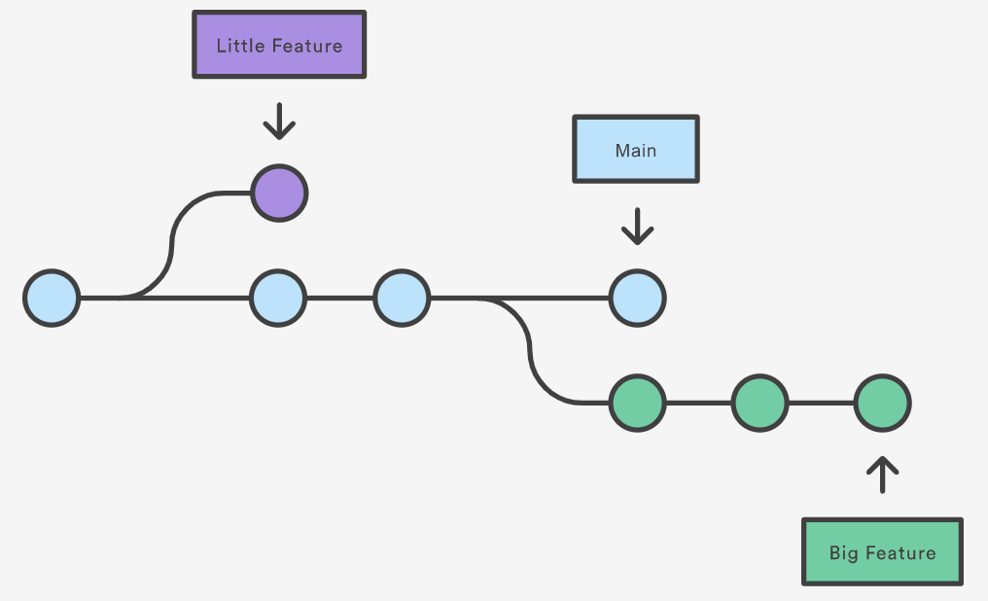
What is a branch? Why do we need it?
A branch represents an independent line of development. Branches serve as an abstraction for the edit/stage/commit process.
By developing in branches, it’s not only possible to work on multiple features in parallel, but also to keep the main branch free from questionable code.

[Source and more details]

How to create a new branch?
- git checkout -b <new_branch_name>

How to see existing branches?
- git branch

How to switch between existing branches?
- git checkout <brach_name>

What is a PR (pull request)?
Pull requests are a mechanism for developers to show and discuss the work they have completed.
If there are any problems with the changes, teammates can post feedback in the pull request and even tweak the feature by pushing follow-up commits.

What is a code review?
Code review (also referred to as peer review) is an activity in which one or several people check a program mainly by viewing and reading parts of its source code.
During code review, teammates may provide suggestions on how to improve the code they are reviewing.

What is a merge conflict?
Multiple engineers sometimes may try to change the same file (set of files).
Conflicts generally arise when two people have changed the same lines in a file, or if one developer deleted a file while another developer was modifying it. In these cases, Git cannot automatically determine what is correct.
To alleviate the occurrence of conflicts developers will work in separate isolated branches.

How to solve a conflict?
The most direct way to resolve a merge conflict is to edit the conflicted file. Once the file has been edited use git add to stage the new merged content. To finalize the merge, create a new commit.
Git will see that the conflict has been resolved and create a new merge commit to finalize the merge.
[Detailed step by step tutorial on resolving a conflict]

